1 | Create a NumPy array representing reflectivity values measured at 3 temperatures over 4-time intervals.  Task:  - Create the array using NumPy.  - Reshape it into a 3 × 4 matrix.  - Extract the second column using slicing.  Reverse the order of columns.
2 | Generate a NumPy identity array (4x4) and an eye array. Reshape a flat array of 12 elements into 3x4 and 4x3; perform transposition and flattening. Illustrate iterating over the reshaped array with code for environmental sensor data simulation.
3 | Make a sample CSV dataset into a Pandas DataFrame (e.g., sales data). Apply reindexing to add a new index, drop missing entries, select specific columns via loc/iloc, and compute summary statistics (mean, std). Explain data alignment issues resolved.
4 | Obtain a real-world dataset related to weather or environmental sensing from an open data source or API.  Task:  - Load the dataset into Pandas.  - Display summary statistics using built-in functions.  - Sort the data based on one numerical column.  - Rank the entries based on that column.
5 | Write a NumPy program to perform the following operations:  a) Create a 6 × 6 array containing numbers from 1 to 36.  b) Reshape the array in n*n format and display it.  c) Extract the central 4 × 4 sub-array using slicing.  d) Replace all even numbers in the sub-array with 0 using boolean indexing.  e) Compute row-wise and column-wise sums of the modified sub-array.  f) Extract elements greater than 20 from the original array.  g) Replace all numbers divisible by 5 in the original array with -1.  h) Find the maximum, minimum, and mean values of the modified array.  i) Display the transpose of the final array.  j) Flatten the array into a 1D array and sort it.
6 | Write a Python program using Pandas to perform the following operations:  - a) Create a DataFrame containing student details below.  - 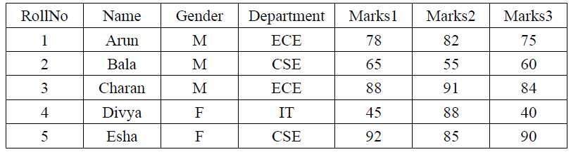  b) Display the first and last five records of the Data Frame.  c) Add a new column Total Marks and compute total marks.  d) Add another column Average Marks.  e) Filter students who scored average marks greater than 70.  f) Display only Name and Total Marks columns.  g) Replace marks less than 40 in any subject with NaN.  h) Count the number of missing values in each column.  i) Sort the DataFrame based on Total Marks in descending order.  j) Group students by Department and compute average total marks.
7 | Using NumPy array slicing, extract the elements highlighted in different colours from the given array  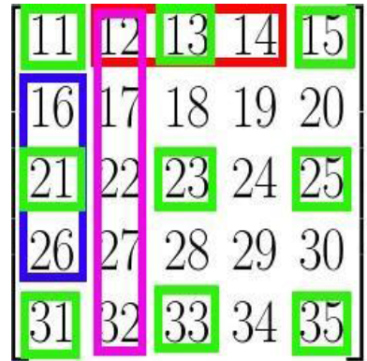
8 | You are given the following list of daily temperatures (°C) recorded over 12 days:  [32, 34, 35, 33, 31, 30, 29, 28, 27, 29, 31, 33]  Write a Python program using the Pandas Series to perform the following operations:  - Create a Pandas Series named temp_series from the above list. (1 Mark)  - Display the first 5 and last 5 values of the series. (1 Mark)  - Find the mean, median, and standard deviation of the temperatures. (2 Marks)  - Identify the maximum and minimum temperature along with their index positions. (2 Marks)  - Replace all temperature values below 30°C with the value NaN. (1 Mark)  - Count the number of missing values after replacement. (1 Mark)  - Sort the series in descending order and display the top 3 highest temperatures. (1 Mark)  - Apply a function to convert Celsius to Fahrenheit and display the updated series. (1 Mark)
9 | A university maintains the following data of 8 students:  Write a Python program using Pandas DataFrame to perform the following tasks:  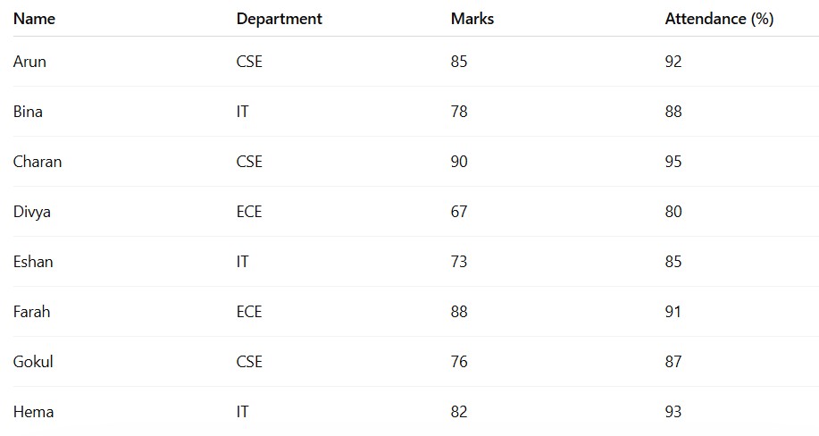  1. Create a DataFrame named `student_df` from the above data.  2. Display the first 3 and last 3 records of the DataFrame.  3. Display only the `Name` and `Marks` columns.  4. Find the average marks of all students.  5. Find the department-wise average marks using groupby.  6. Add a new column `Result` such that:  * Marks ≥ 80 → "Distinction"  * Marks 60–79 → "Pass"  * Marks < 60 → "Fail"  7. Display the details of students having attendance greater than 90%.  8. Sort the DataFrame by `Marks` in descending order and display top 2 students.
10 | Air pollution data is available on a public environmental monitoring webpage that lists City Name, AQI (Air Quality Index), PM2.5, PM10, and Status (Good/Moderate/Poor) in a table format.  Write a Python program using Requests, BeautifulSoup, and Pandas to create a user-defined dataset from the webpage.  Perform the following tasks:  - Import the required libraries (requests, bs4, pandas). (1 Mark)  - Send an HTTP request and download the HTML content of the webpage. (1 Mark)  - Parse the HTML page using BeautifulSoup and locate the pollution data table. (2 Marks)  - Extract the following fields for all available cities:  - City  - AQI  - PM2.5  - PM10  - Status (2 Marks)  - Store the extracted data into a Pandas DataFrame named air_df. (1 Mark)  - Display the first 5 records and summary statistics of AQI. (1 Mark)  - Save the dataset into a CSV file named air_pollution_dataset.csv. (1 Mark)  - Filter and display cities where AQI > 150 (Unhealthy level). (1 Mark)

